DESIGN TASK

OUTPUT LINK
https://parser-visualizer.vercel.app

Q1. Predictive Parser Design (Application Level)
Task:
Construct an LL(1) predictive parsing table and parse the input.
Grammar:
S → A B
A → a A | ε
B → b B | ε
Conditions:
• Compute FIRST and FOLLOW
• Construct LL(1) table
Test Case:
Input:
aaabbb
Expected Output:
• Step-by-step parsing
• String Accepted

Q2. Shift-Reduce Parsing (Application Level)
Task:
Apply shift-reduce parsing.
Grammar:
E → E + E
E → id
Conditions:
• Left associative
Test Case:
Input:
id + id + id
Expected Output:
• Actions
• Accepted
Q3. LR Parsing Design (Application Level)
Grammar:
S → A A
A → a A | b
Tasks:
(i) CLR
(ii) SLR
(iii) LALR
(iv) Parse: ab
Show stack, input, actions
CODE

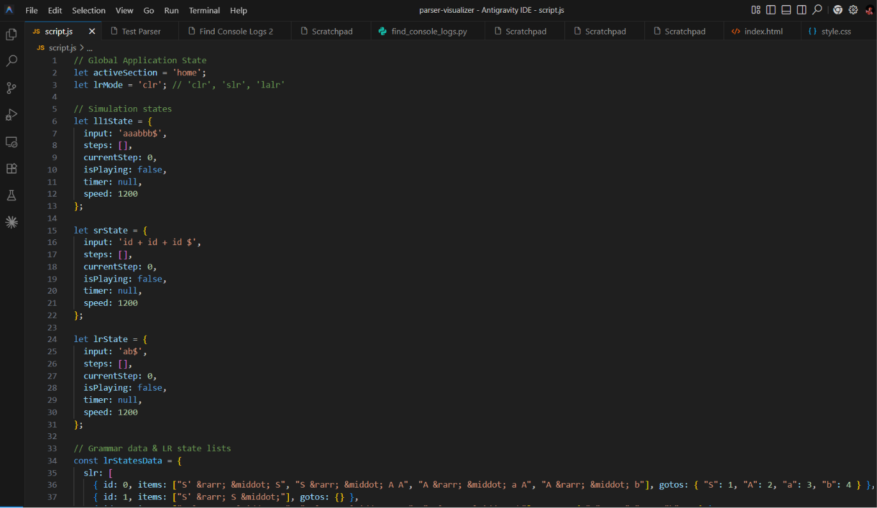

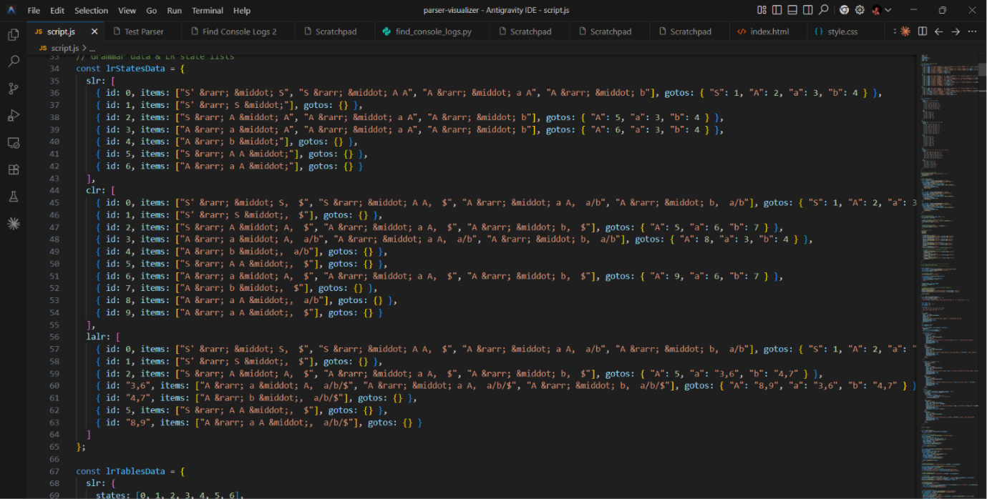

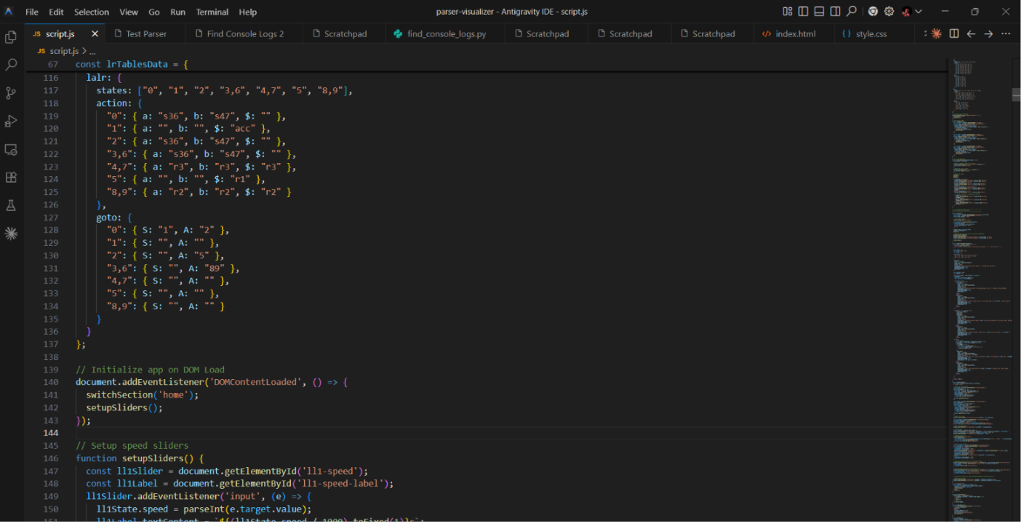

OUTPUT
